SAILING INSTRUCTIONS

Abbreviations

PC – protest committee RC – race committee
OA – organising authority TD – World Sailing technical delegate
RRS – racing rules of sailing SI – sailing instructions
IJ – international jury NoR – notice of race
RCV – race committee vessel PWSC – Para World Sailing Committee

This is a copy of the Blind Match Racing World Championship Sailing Instructions. It is being supplied as a Word Document for accessibility reasons.

1 RULES
1.1 The Event will be governed by
(a) the ‘rules’ as defined in the RRS, including Appendix CBS (Nov 2017).
(b) The rules for the handling of boats (SI Addendum C) will apply and will also apply to any practice sailing and sponsor races.
(c) Class rules will not apply.
1.2 An IJ will be appointed in accordance with RRS Appendix N, and the right of appeal will be denied in accordance with RRS 70.5. A letter from the World Sailing will be displayed on the official notice board approving the membership of the IJ, as per RRS N1.7.
1.3 Add to RRS 41: (e) help to recover from the water and return on board a crew member, provided the return on board is at the approximate location of the recovery.
1.4 Delete RRS CBS6.3 and replace with: A boat intending to request redress because of circumstances that arise while she is racing or in the finishing area, shall clearly display a red flag as soon as possible after she becomes aware of those circumstances, but no later than two minutes after finishing or retiring.
1.5 When the umpires proceed under RRS CBS 8.6 they will follow the guidance in SI Addendum E.
1.6. International Blind Sports Federation (IBSA) Medical and Protest Procedures will be adopted for this event with the following changes:
1.6.1. Classifiers are not required to be accredited IBSA International Classifiers
1.6.2. Classifiers may classify a competitor from their own country
1.6.3. PWSC shall approve the classifiers and other classification officials
1.7 If the first boat has finished and the second boat in the match has a penalty outstanding, the umpires may signal in accordance with CBS 5.5 that the outstanding penalty is now completed and remove the corresponding flag. Once it has finished, the second boat may then be scored with a loss without the requirement of completing a penalty before finishing. This changes rule CBS 7.4.

2 ENTRIES and ELIGIBILITY
2.1 Only skippers invited by the OA are eligible for the event. The skippers are listed in SI Addendum A
2.2 To remain eligible the entire crew shall complete registration, pay any entry fee, deposit £250 for damage and complete an ophthalmic examination, all before 1700 on 01 September 2018, unless extended by the OA.
2.3 The damage deposit is the limit of liability of each skipper for each incident. In the event that a deduction is made from the deposit, the skipper will be required to restore the deposit to the original value to maintain eligibility.
2.4 Each skipper is responsible for the damage or loss to their boat unless responsibility is otherwise assigned by the umpires or IJ.
2.5 After the warning signal for a match, the registered skipper shall not leave the helm, except in an emergency.
2.6 When a registered skipper is unable to continue in the event, the TD may authorise an original crew member to substitute.
2.7 When a registered crew member is unable to continue in the event, the TD may authorise a substitute, a temporary substitute or other adjustment.

3 COMMUNICATIONS WITH COMPETITORS
3.1 Notices to competitors will be posted on the official notice board located within the Rhu Marina marquee.
3.2 Signals made ashore will be displayed from the flagpole in proximity to the marquee at Rhu Marina.
3.3 Skippers shall attend the first briefing, which will be at 1600 on 2nd September 2018 in the RNCYC clubhouse, unless excused by the OA.
3.4 The first meeting with the umpires will follow on from the first briefing.
3.5 A daily morning meeting will take place - timings and location will be announced at the first briefing.

4 AMENDMENTS TO SAILING INSTRUCTIONS
4.1 Amendments to the SI made ashore will be posted by 1900 hours the day before the start of any race affected and will be signed by the RC and the TD.
4.2 Flag L over the numeral pennant of the most recent amendment will be displayed ashore each day until the boats have departed for the race course.
4.3 Amendments made afloat will be signalled by the display of flag 3rd substitute with three sound signals. An umpire may communicate these verbally.

5 BOATS and SAILS
5.1 Boats
(a) the event will be sailed in Sonar-like boats.
(b) the sails to be used will be allocated by the RC.
(c) competitors may be requested to exchange sails during a series to satisfy sponsorship commitments. This will not be grounds for redress. This changes RRS 62.
5.2 The sail combination to be used is mainsail and jib.
5.3 Other restrictions or instructions may be given to the boats verbally by an umpire. Flag 3rd substitute is not required.
5.4 The RC will decide which boats are to be used for each stage and when they decide a boat should not be used, the skipper assigned that boat will be given the temporary use of another boat.
5.5 The RC may permit a substitute boat when it is satisfied that the original boat is damaged and that repairs in the time available are not practical.
5.6 The acoustic tack signalling device, the transceivers set and the flags will be allocated by the RC.

6 IDENTIFICATION and ASSIGNMENT OF BOATS
6.1 Boats will be identified by Sail Number.
6.2 Boats will be drawn at the beginning of each stage or as decided by the RC.
6.3 Boats will be allocated by the OA for the stage in accordance with a pre-determined draw.
6.4 Boats will be exchanged in accordance with the pairing list and race schedule.

6.5 Boats will display yellow and blue flashes on their mainsails as provided by the OA according to whether they are allocated the port (blue) or starboard (yellow) side of the course. This changes RRS CBS4.1

7 CREW MEMBERS, NUMBER
7.1 The total number of crew, including the skipper, shall be 3.
7.2 The crew shall conform to the Classification requirements as given in World Sailing Race Management Manual for Para-Sailing Events 2017-2020.
7.3 All registered crew shall sail all matches unless permission for change is given under SI 2.6 or 2.7.
7.4 Competitors are reminded of CBS2.16, which states:
Competitors shall wear personal flotation devices, except briefly while changing or adjusting clothing or personal equipment at all time while afloat. Wet suits and dry suits are not personal flotation devices.

8 EVENT FORMAT and STARTING SCHEDULES
8.1 The event format and match pairing lists are detailed in SI Addenda A and B. Each flight will consist of one match only. The matches to be sailed will be communicated in order of starting by the RC boat.
8.2 In a knock-out series between two skippers:
(a) they will alternate assigned ends for each match. Unless designated in the pairing list, the initial assigned ends will be determined by a draw. This changes RRS CBS4.1.
(b) when the series has been decided, further matches between these two will not be sailed.
(c) crews will exchange boats after odd matches of the series, unless otherwise agreed by both skippers.

8.3 The racing days are scheduled as 3rd to 7th September.
8.4 The latest time for an attention signal on the last day of racing will be approximately 1400.
8.5 The number of matches to be sailed each day will be determined by the RC.
8.6 The RC may change the format, terminate any stage or the event when, in its opinion, it is impracticable to attempt to hold the remainder of matches under the existing conditions or in the remaining time scheduled. Early stages may be terminated in favour of later stages.
8.7 The intended time of the first attention signal each day is 1000.
8.8 Each subsequent flight will be started as soon as practicable after the previous flight.
8.9 When a match cannot start at its intended time, the signals and starts of the following matches will move forward but keeping their sequence flags.
8.10 When, in a knock out series, a winner of a particular series has been determined, subsequent starts will be brought forward to eliminate blank starts. Competitors will be so advised verbally by an umpire.

9 RACING AREA
The intended course area will be The Firth of Clyde or the Gareloch. The race areas are shown at Addendum F. The Race Area, if other than Area 1, will be announced at the daily briefing. An Admiralty chart of the racing area will be available for inspection at registration.

10 COURSE

10.1 Configuration, Signals and Course to Be Sailed
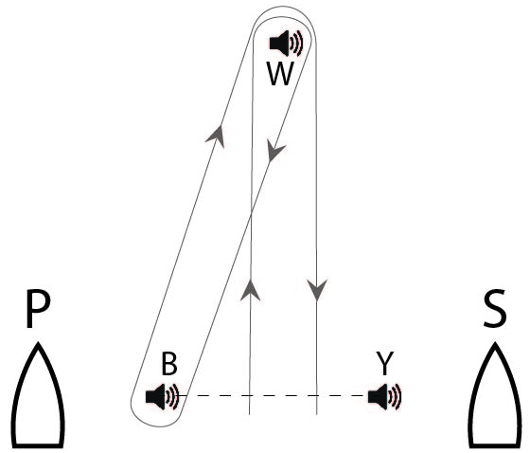
(a) The configuration of course (not to scale) is shown below. The RCV will be positioned on an extension of the start/finish line, either to Port (P) or Starboard (S).
(b) Signals and Course to be Sailed
Course signals will be displayed from the RC boat at or before the warning signal.
Marks W and B shall be rounded to starboard.
Signal Course
No Signal* Start - W - B - W - Finish
S Start - W - Finish
(c) Description of Marks
The RCV will be a vessel as detailed in the first briefing
The starting/finishing line mark(s) and Marks W will be detailed at the first briefing together with the sounds that each make.

10.2 Starting/Finishing Line
(a) The starting/finishing line will be a straight line between the course side of two starting/finishing line marks.
(b) A committee vessel will be anchored on an extension of the start finish line. This vessel is an obstruction
(c) A buoy may be attached to the RC boat anchor line just below keel depth. Boats shall not pass between this buoy and the RC boat at any time. This buoy is part of the RC boat ground tackle.
(d) A buoy or float may be attached to the stern of the committee boat.

10.3 Abandonment and Shortening
(a) RRS 32 is deleted and replaced with: ‘After the starting signal, the RC may abandon or shorten any match for any reason, after consulting with the match umpires when practical.’

11 BREAKDOWN and TIME FOR REPAIRS
11.1 Before the attention signal of a flight or within two minutes of finishing or within five minutes of changing into a new boat, whichever is later, a boat may display a white flag (provided) to signal breakdown or damage to the boat, her sails or injury to her crew and request a delay to the next start. She shall proceed as soon as possible to a position just to leeward of the RC boat and remain there, unless otherwise directed.
11.2 The time allowed for repairs will be at the discretion of the RC.
11.3 After the attention signal of a flight, a match will not be postponed or abandoned due to breakdown unless the breakdown signal was displayed as required by SI 11.1.
11.4 Except when RRS 62.1(b) applies, failure to effect repairs in the time allowed, or breakdowns after the attention signal shall not be grounds for redress. This changes RRS 62.

12 STARTING PROCEDURE
12.1 Match warning signals will be as per CBS 3.1.
12.2 The next race number will be displayed on the RCV.

13 CHANGE OF POSITION OF THE WINDWARD MARK
13.1 The RC may adjust the course during the match to keep it square. Any adjustment will be hailed over VHF radio

13.2 In the case of failure of acoustic mark B, or a wind shift, the RC may direct by radio that the boats are to round mark Y instead of mark B. Such direction applies to the match in progress only, unless the RC decides differently.

14 TIME LIMIT
A boat that does not finish within 5 minutes after her opponent has completed the course and finished will be scored DNF. This changes RRS 35 and A5.

15 COACHES & COACH BOATS

15.1 Each team is permitted a coach on-board prior to and between races. Coaches will be removed from the boats prior to the Warning Signal.

Coaches will be returned to the boats at the earliest opportunity after the boat has crossed the finish line or the race has been concluded.
15.1 The OA-provided ribs will collect coaches from boats, and will allow coaches to observe racing and communicate with their teams between matches. Individual coach boats are permitted at the discretion of the OA.
15.2 Any interference by a coach or individual coach boat with the racing or event organisation may result in a penalty applied at the discretion of the IJ to the associated skipper or team.

16 MEDIA, IMAGES and SOUND
16.1 If required by the OA:
(a) Media personnel and equipment (or dummies) supplied by the OA shall be carried on board while racing.
(b) Competitors shall be available for interviews when advised by the OA or RC.
16.2 Competitors shall not interfere with the normal working of the OA supplied media equipment.
16.3 The OA have the right to use any video, images and sound recorded during the event free of any charge.

17 PRIZES
17.1 The winning team will be awarded the Title of World BMR Champion. World Sailing medals will be awarded to the 1st, 2nd and 3rd teams
17.2 Additional prizes will be awarded at the discretion of the OA.

18 CODE OF CONDUCT
18.1 Competitors shall comply with any reasonable request from any official, including attendance at official functions, co-operation with event sponsors and shall not behave so as to bring the event into disrepute.
18.2 Competitors shall handle the boats and equipment with proper care and seamanship and in accordance with SI Addendum C and D.
18.3 The following actions by skippers and/or crew while racing may be considered a breach of sportsmanship under RRS CBS8.3(c) and may result in an umpire initiated penalty under RRS CBS5.2 or CBS5.3:
- Excessive attempts to verbally coerce, coach or influence umpire decisions;
- Repetitive or on-going objection to an umpire decision (verbal or otherwise);
- Abuse of umpires before or after a decision (See also MR Call M4).
18.4 Breaches of this SI may also be referred to the IJ. Any penalty will be at the discretion of the IJ and may include exclusion from further participation in the event, the withdrawal of any prize or the withholding of deposits.
18.5 Gross breaches of this SI may be referred to the IJ by the OA for action under RRS 69.

19 DISCLAIMER
All those taking any part in the event do so at their own risk. The OA, its associates and appointees accept no responsibility for any loss, damage, injury or inconvenience incurred, howsoever caused.

RISK STATEMENT
Rule 4 of the Racing Rules of Sailing states: "The responsibility for a boat's decision to participate in a race or to continue racing is hers alone."
Sailing is by its nature an unpredictable sport and therefore inherently involves an element of risk. By taking part in the event, each competitor agrees and acknowledges that:
(a) They are aware of the inherent element of risk involved in the sport and accept responsibility for the exposure of themselves, their crew and their boat to such inherent risk whilst taking part in the event;
(b) They are responsible for the safety of themselves, their crew, their boat and their other property whether afloat or ashore;
(c) They accept responsibility for any injury, damage or loss to the extent caused by their own actions or omissions;
(d) Their boat is in good order, equipped to sail in the event and they are fit to participate;
(e) The provision of a race management team, patrol boats and other officials and volunteers by the event organiser does not relieve them of their own responsibilities;
(f) The provision of patrol boat cover is limited to such assistance, particularly in extreme weather conditions, as can be practically provided in the circumstances;
(g) It is their responsibility to familiarise themselves with any risks specific to this venue or this event drawn to their attention in any rules and information produced for the venue or event an to attend any safety briefing held for the event;

20 NARROW CHANNELS & QUEEN’S HARBOUR REGULATIONS
20.1 Narrow Channels. Attention is drawn to the International Regulations For The Prevention Of Collisions At Sea, 1972. Particular notice should be taken of rule 9(b) which states that a vessel of less than 20 metres in length, or a sailing vessel, shall not impede the passage of a vessel which can safely navigate only within a narrow channel or fairway. Any Waters of the Firth of Clyde, must be regarded as a narrow channel. This applies in waters of the Queen’s Harbour, which includes the whole of the Gareloch and the approaches to the Gareloch.
20.2 While racing, any yacht that is unable for reasons of lack of wind, or any other cause, to sail clear of a large power driven vessel shall paddle in order to get clear and thereafter shall report full details to the RC. In the event of the RC observing that a yacht has apparently obstructed the safe passage of a large power driven vessel, the RC may proceed against the yacht in accordance with RRS 60.2.
20.3 Any Yachts passing between Navy launches or Seariders and the vessels they are escorting or, otherwise impeding these vessels they are escorting or otherwise impeding these vessels are liable to be impounded and the skipper and crews arrested.

21 NAVAL MOVEMENTS
21.1 In Addition to the above, IC Flag “D” will be flown from the RC Boat if RC is aware that a large Naval vessel may enter the race area during the race schedule.

SI ADDENDUM A – LIST OF ELIGIBLE SKIPPERS

Letter | Country/Team | Helm | Helm WS ID
A | AUS | Kylie Forth | AUSKF3
B | CAN | David Brown | CANDB16
E | GBR/2 | Sally Rodrigues | GBRSR73
I | USA | Walter T. Raineri | USAWR60
H | GBR/1 | Sharon Grennan | GBRSG42

SI ADDENDUM B – EVENT FORMAT and SCHEDULE OF RACES

EVENT FORMAT
1 First Stage - Round Robin(s)

(a) All skippers will sail a continuous round robin until a time at the discretion of the RC.
(b) The 4 highest scoring skippers shall qualify for the next stage.

2 Second Stage – Semi-finals

(a) The highest scored skipper from Stage 1 shall choose their opponent when requested by the RC to do so. The remaining two (2) skippers shall race each other.

(b) In each semi-final the higher scored skipper from Stage 1 will choose its entry in the first match.

(c) The first two (2) skippers to score at least two (2) points shall proceed to the finals. The other two (2) shall proceed to the Petit Finals.

3 Third Stage – Petit Finals

(a) The higher scored skipper from Stage 1 will choose its entry in the first match.
(b) The first skipper to score at least two (2) points shall be awarded third place, the other fourth place.

4 Fourth Stage –Finals

(a) The higher scored skipper from Stage 1 will choose its entry in the first match.
(b) The first skipper to score at least three (3) points will be the winner, the other second place.

SI ADDENDUM C – HANDLING of BOATS

1 GENERAL
While all reasonable steps are taken to equalise the boats variations will not be grounds for redress. This changes RRS 62.

2 PROHIBITED ITEMS and ACTIONS - Except in an emergency or in order to prevent damage or injury, or when directed by an umpire otherwise, the following are prohibited:
2.1 Any additions, omissions or alterations to the equipment supplied.
2.2 The use of any equipment for a purpose other than that intended or specifically permitted.
2.3 The replacement of any equipment without the sanction of the RC.
2.4 Sailing the boat in a manner that it is reasonable to predict that significant further damage would result.
2.5 Moving equipment from its normal stowage position except when being used.
2.6 Boarding a boat without prior permission.
2.7 Taking a boat from its berth or mooring without having paid the required damage deposit or having permission from the RC, or, on race days, while ‘AP’ is displayed ashore.
2.8 Hauling out a boat or cleaning surfaces below the waterline.
2.9 Marking directly on the hull or deck with permanent ink, or using any tape that leaves a residue/ use of duct tape.
2.10 Using a flattener as a reef or using a reef line as an outhaul.
2.11 Adjusting or altering the tension of standing rigging, excluding the backstay.
2.12 Using the spinnaker pole to wing out the foresail.
2.13 Perforating sails, even to attach tell tales.
2.14 Radio transmission (including mobile telephones), except to report damage or in response to a request from the RC.
2.15 The use of electronic equipment, unless permitted by SI C3.1.
2.16 Hiking outside the hull, as defined in the Sonar Class rules, c.f. “A crew member shall be seated inboard of the toe rail (including legs) but the upper body may lean outboard.”
2.17 The use of the shrouds (including any inner shrouds) above the lower bottle screw (turnbuckle) to facilitate tacking or gybing, or to aid the projection of a crew member outboard is prohibited.
2.18 Adding, removing, or altering the position of mast “chocks”.
2.18 A breach of SI C2.16, C2.17 and C2.18 is not open to protest by boats but is subject to action by Umpires in accordance with RRS CBS 8.2. This changes RRS CBS 6.2 and CBS 8.2.

3 PERMITTED ITEMS and ACTIONS – the following are permitted:
3.1 Taking on board the following equipment:
(a) basic hand tools
(b) adhesive tape
(c) line (elastic or otherwise of 4 mm diameter or less)
(d) tell tale material
(e) hand held compasses, watches, timers and small personal video devices such as GoPro
(f) shackles and clevis pins
(g) velcro tape
(h) spare flags
(i) PFD's when not supplied by the OA
3.2 Using the items in 3.1 to:
(a) prevent fouling of lines, sails and sheets
(b) attach tell tales
(c) prevent sails being damaged or falling overboard
(d) mark control settings
(e) make minor repairs and permitted adjustments
(f) make signals as per Appendix C6
(g) personal safety
3.3 Changing the number of mainsheet purchases.

4 MANDATORY ITEMS and ACTIONS – the following are mandatory:
4.1 The completion of a written damage report before leaving a boat and submitting it to the RC, even if no damage or loss is recorded. Reports shall include any evidence of matters which could cause damage or disadvantage to the boat in future matches. When boat swaps are carried out on the water, the report should be made verbally to the RC as soon as possible.
4.2 At the end of each sailing day:
(a) folding, bagging and placement of the sails as directed
(b) leaving the boat in the same state of cleanliness as when first boarded that day
(c) releasing backstay tension
(d) Securely fastening the tiller with the backstay and additional lines as appropriate
4.3 At the end of the final day for a particular boat, cleaning the boat (cabin and decks), removing all trash and removing all tape and marks.
4.4 Any request to alter, in any way, the equipment on a boat shall be in writing and worded to permit a yes/no answer.
4.5 Complying with any regulations, including speed restrictions and navigation marks, while leaving or returning to the berth or mooring.
4.6 A breach of items 4.2 and 4.3 will be considered as damage and the cost of rectification will be deducted from the damage deposit.

SI ADDENDUM D – EQUIPMENT LIST

The following non-fixed items, provided by the OA, are to be carried on board at all times in their designated place while sailing. Any loss shall be reported on the daily damage report.

SAILS and SAILING EQUIPMENT

Mainsail and set of battens
Jib
headsail sheet(s)
Tiller extension

SAFETY GEAR

Bucket and lanyard

GROUND TACKLE

Anchor and chain
Anchor line

MOORING LINES and FENDERS

Two mooring lines
Fender(s)

PARA SAILING ITEMS

Tack indicator with batteries and sounder
Comms Device to allow the Umpires to warn of unseen danger

SI ADDENDUM E – DAMAGE PENALTIES

Match Racing Penalties for Damage resulting from contact between boats
Appendix CBS6.6 and CBS8.6 permits the umpires or protest committee to decide the penalty when a boat breaks RRS 14. This document explains how damage will be assessed and gives general guidance on the appropriate penalty. When the protest committee has good reasons to do so, it may apply a different penalty.
Damage will be divided into 3 levels as shown in the following table:

Level | Extent | Effect
Level A - Minor Damage | Does not significantly affect the value, general appearance or normal operation of the boat. | Boat may race without repair although some minor surface work may be required after the event. Repairs should not normally require more than 1 hour of work.
Level B - Damage | Affects the value and/or general appearance of the boat | The damage does not affect the normal operation of the boat in that race but may need some (temporary) work before racing again. Requires more than 1 hour of work but should not normally require more than 3 hours of work.
Level C - Major Damage | The normal operation of the boat is compromised and its structural integrity may be impaired. | The boat will need some repair work before racing again. Requires more than 3 hours of work.

Point Penalties - to be applied without a hearing (this amends RRS C8.6);

Level | Round Robin | Knock Out
A | None | None
B | Half point | Three quarters of a point
C | One point | One point

When both boats break RRS 14, they should both receive a points penalty. If a competitor requests a hearing when a points penalty is imposed, the protest committee may decide (in the hearing) to give a greater penalty.

Deductions from Damage Deposits
The assessment of damage level is only for the purpose of points penalties, and is not linked to any deductions from the competitor’s damage deposits.
Any points penalty will be based on the assessment of damage level made on the water. Subsequent assessments of the damage level after closer inspection, whether the level turns out to be higher or lower, will have no effect on the points penalty given on the water.

SI ADDENDUM F – RACE AREAS

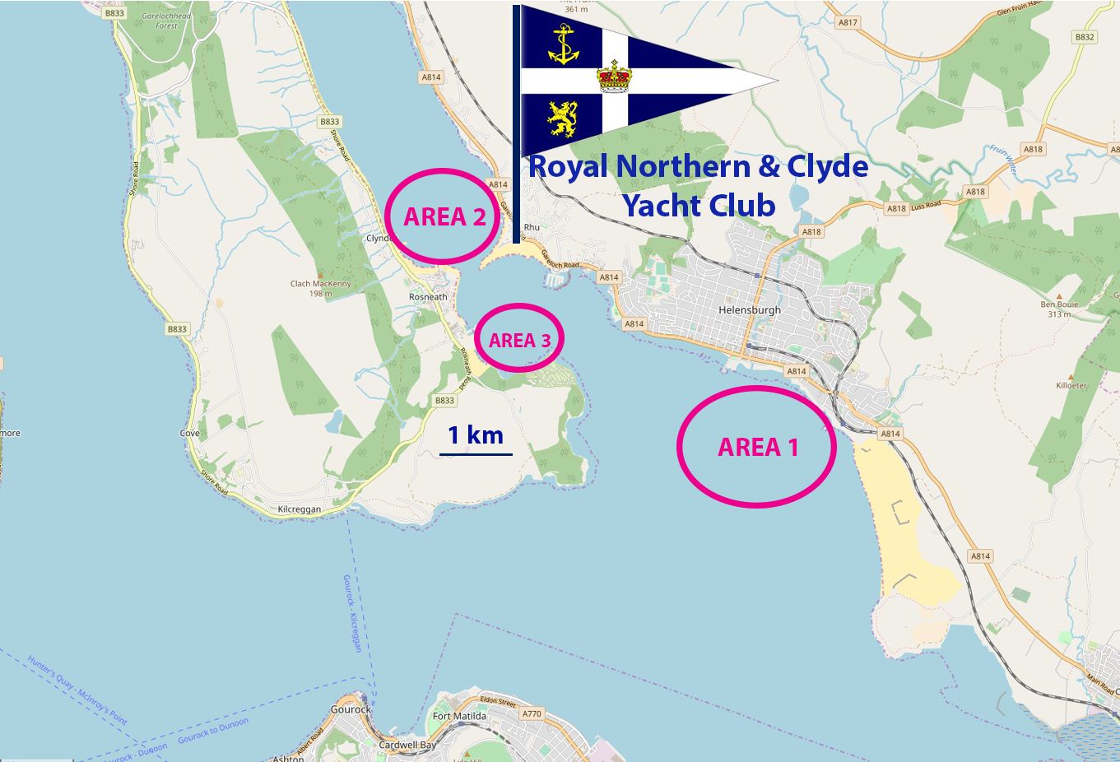
Map © OpenStreetMap contributors

