Amendment to Sailing Instructions #1, 3/9/2018

All of 15 are deleted, and replaced with:

15.1 Each team is permitted a coach on-board prior to and between races. Coaches will be removed from the boats prior to the Warning Signal.

Coaches will be returned to the boats at the earliest opportunity after the boat has crossed the finish line or the race has been concluded.
15.2 The OA-provided ribs will collect coaches from boats, and will allow coaches to observe racing and communicate with their teams between matches. Individual coach boats are permitted at the discretion of the OA.
15.3 In alteration to RRS 64.4(b), any interference by a coach or individual coach boat with the racing or event organisation may result in a penalty applied at the discretion of the IJ to the associated skipper or team.

The purpose of this amendment is to (i) detail that 15.3 results in an RRS rule change, and (ii) to resolve confusion in the numbering of sub-items of 15.

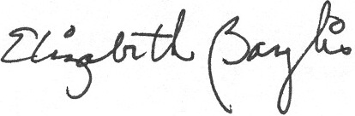
Signed: Liz Baylis
World Sailing Technical Delegate

