Amendment to Notice of Race 31st August 2018

7.3 An IJ will be appointed, and approved by the World Sailing in accordance with RRS Appendix N. A letter from the World Sailing will be displayed on the official notice board approving the membership of the IJ, as per RRS N1.7.

International Jury - Letter

The IJ will have three representatives from the following countries: GBR, USA, IRL.

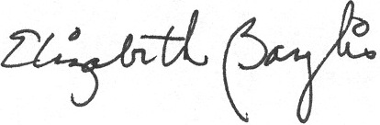
Signed: Liz Baylis
World Sailing Technical Delegate

