ROYAL NORTHERN & CLYDE YACHT CLUB
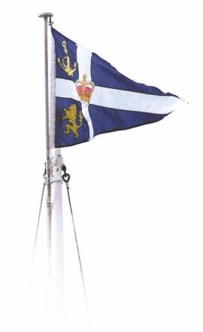

GARELOCH RACES 2023

The Organising Authority is Royal Northern & Clyde Yacht Club

Amendment No. 1
Notice of Race

Replace 9.2 with:

9.2 Racing on Sundays for Gareloch One Deign Class, first warning signal 14.55
Hatasoo Basket, 8 Races April 30, May 7, 14, 21, 28 June 4, 11, 18.
Nyassa Plate, 4 Races July 2, 9, 16, 23.
Armstrong Trophy, 8 Races July 30, August 6, 20, 27, Sept. 3, 10, 17, 24.

